PROCESS FLOW FOR NEW PG STUDENTS
- Visit the UNN Portal www.unnportal.unn.edu.ng
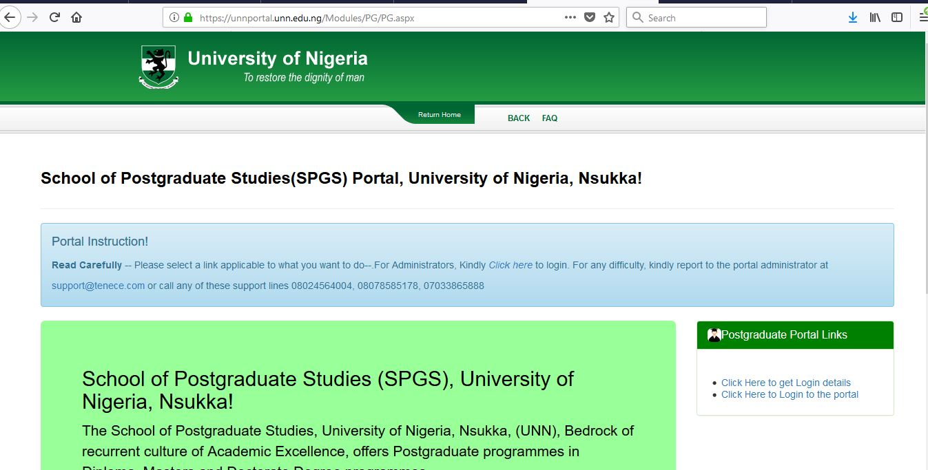

- Click to get login details
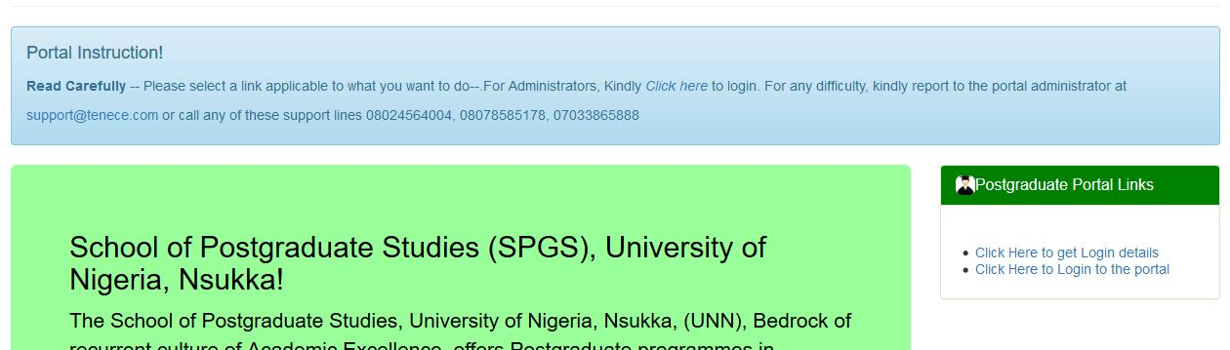

- Select New Student and enter your Application number.
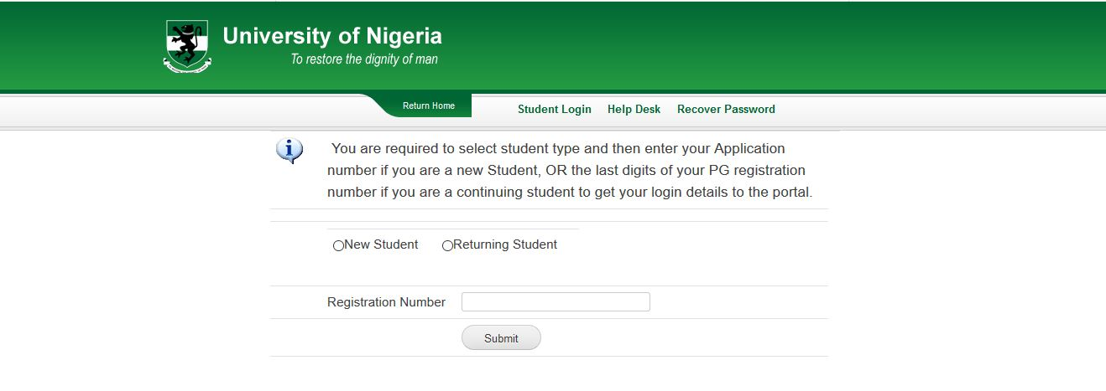
- Login with your Username and Password.

- Complete your profile.

- Generate your acceptance fees invoice.

- Pay at the bank or using your ATM Card.

- Generate School Fees Invoice.

- Pay at the Bank or using your ATM Card.

- Print your Online School Receipt.

- Print your Online School Receipt.

- Print Admission Letter.

- Proceed with other Registration requirements.

